How to Create a Procurement Order (PO) of requisitions on Jibe (For Internal Employee Training Purpose)

- Landing page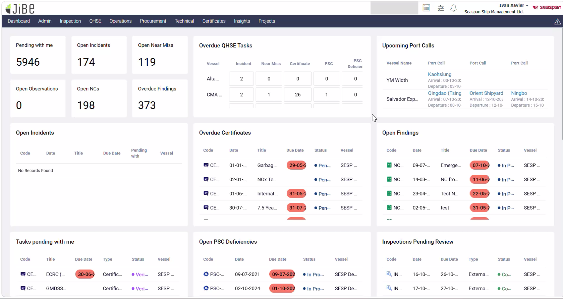
- Hover over Procurement Click on Lists 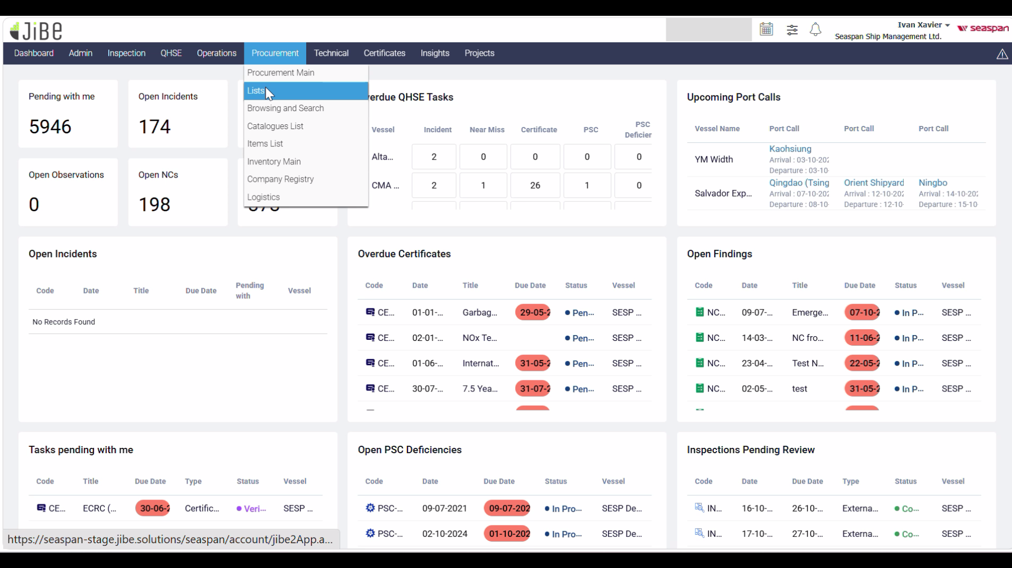
- Click on “Create New” button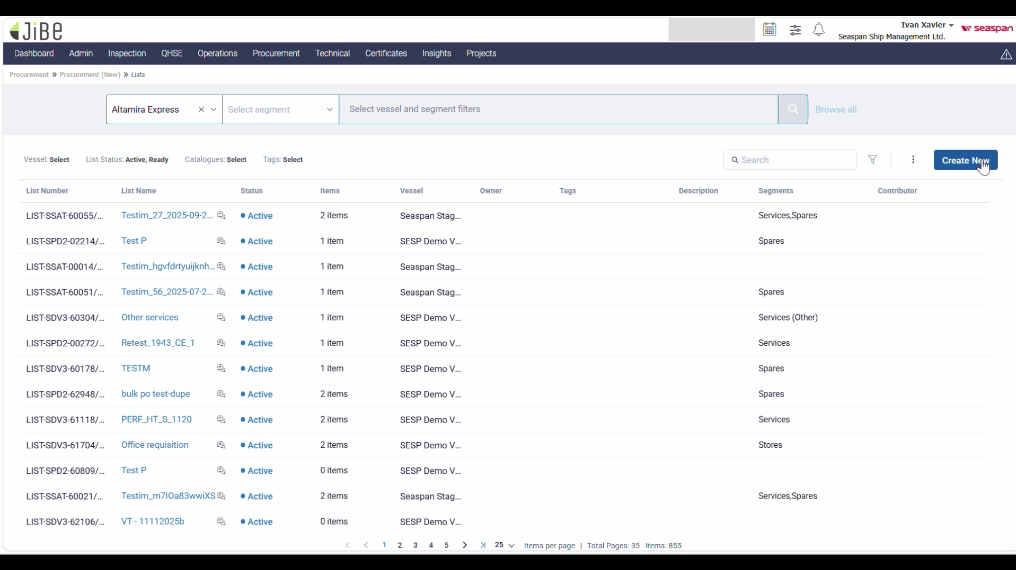
- Create New List box pops up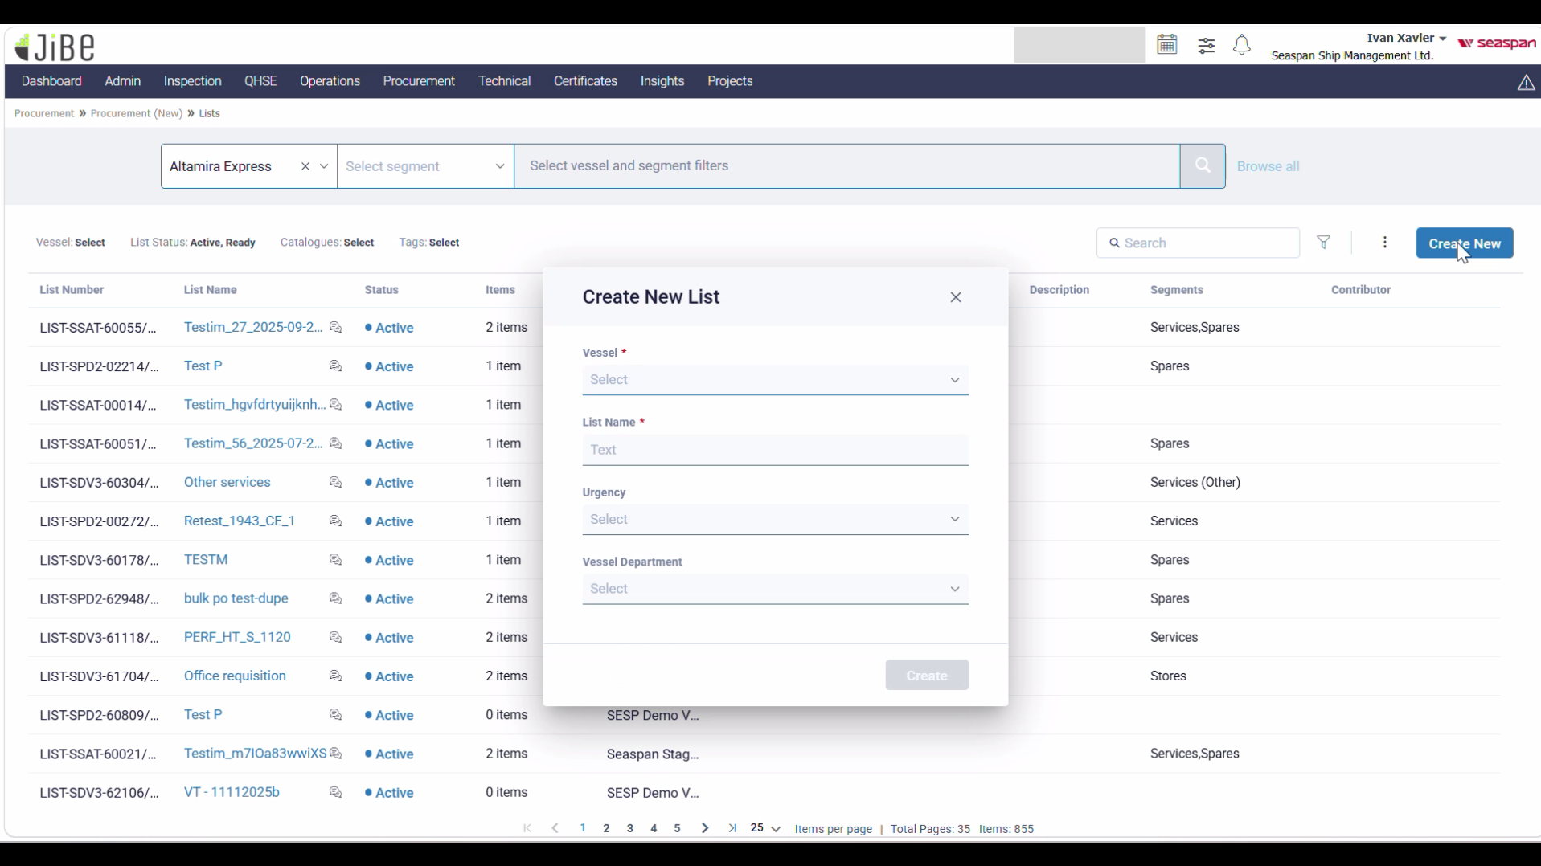
  - Select “SESP Demo Vessel” from list of vessels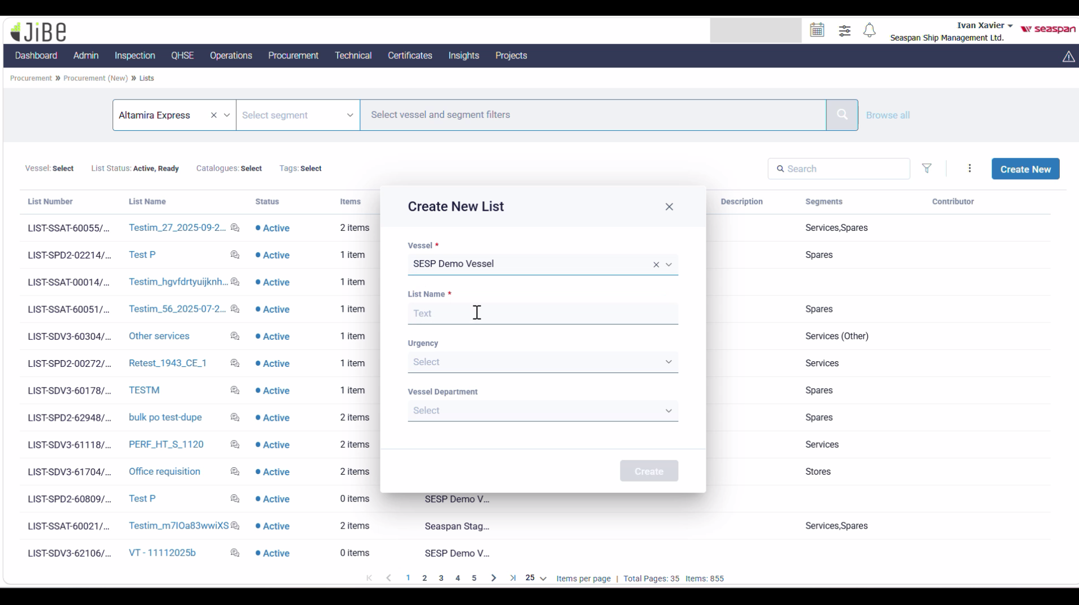
  - Name the list under “List Name” section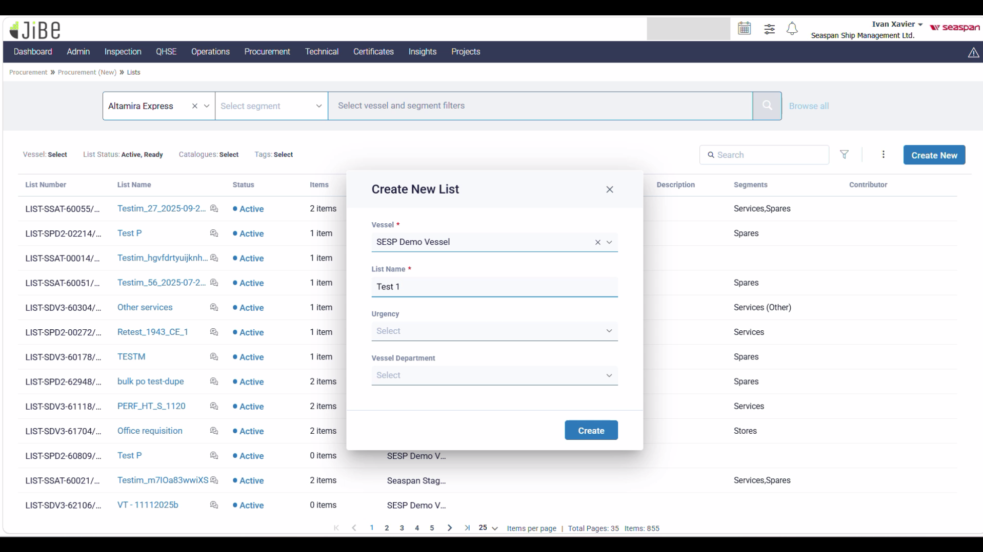
  - Select the urgency from the dropdown list as D-Regular Spares/Stores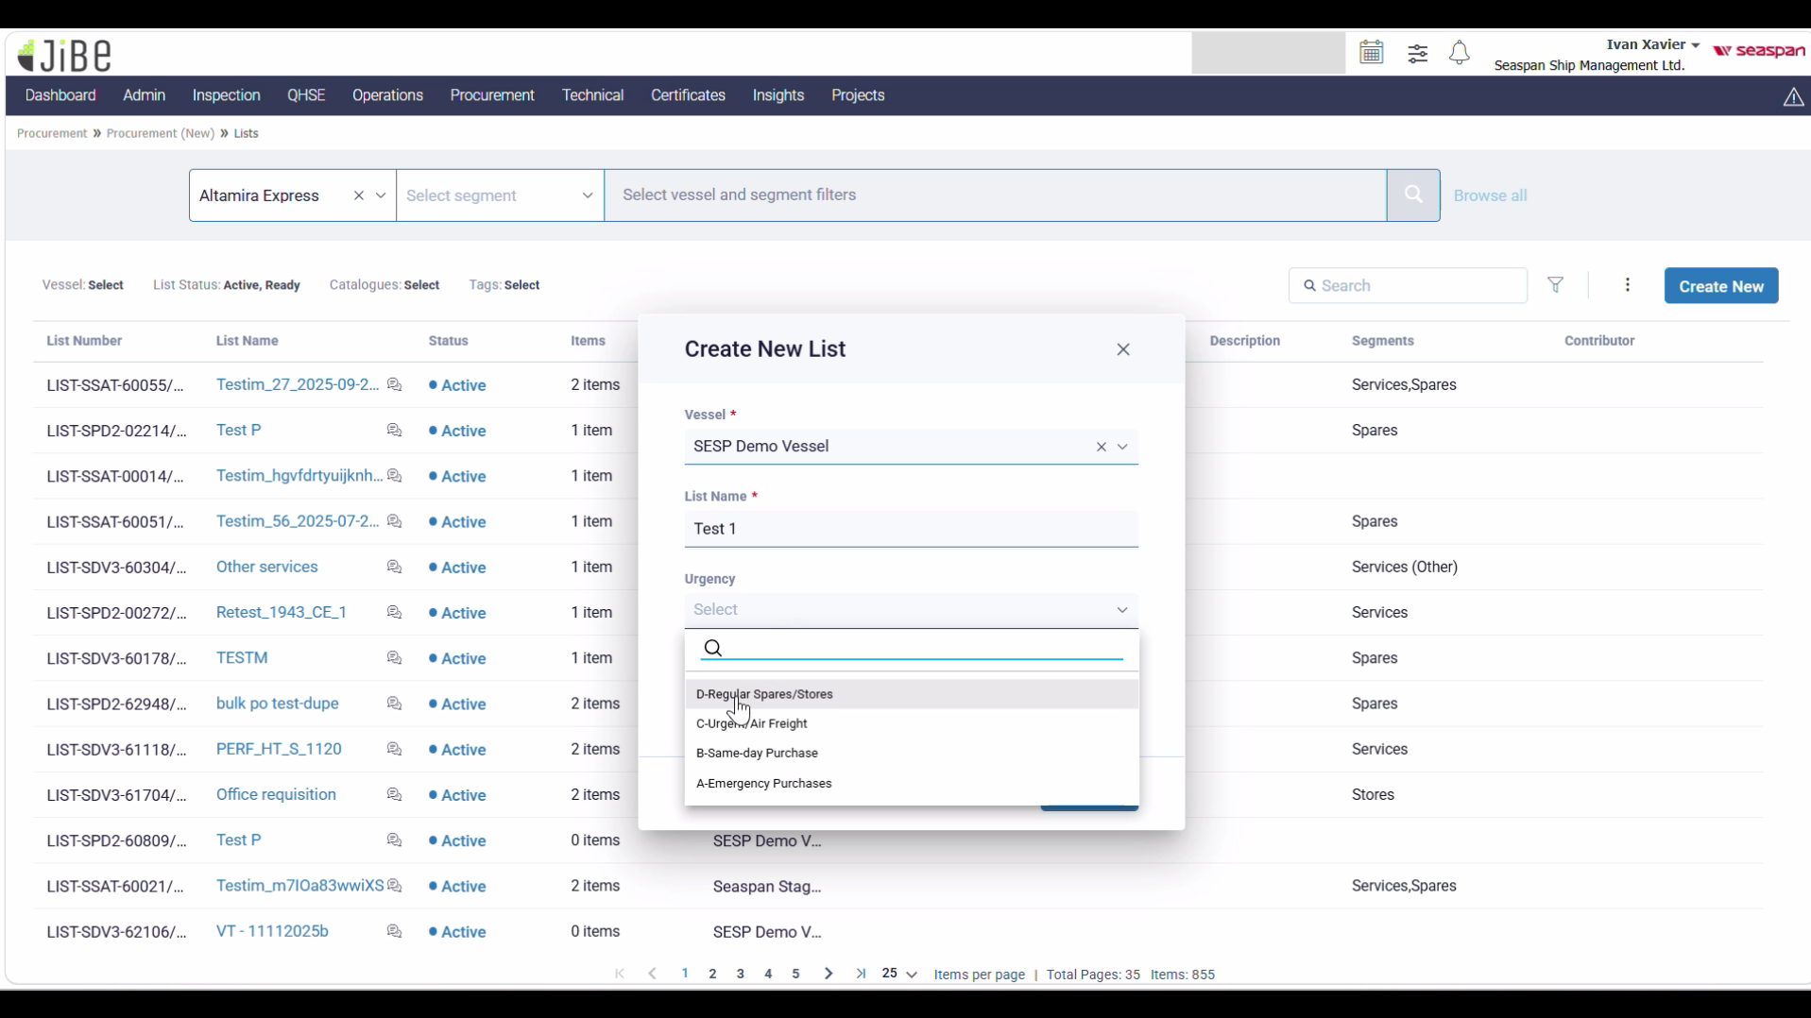
  - Select Vesel Department Engine (For the demo) 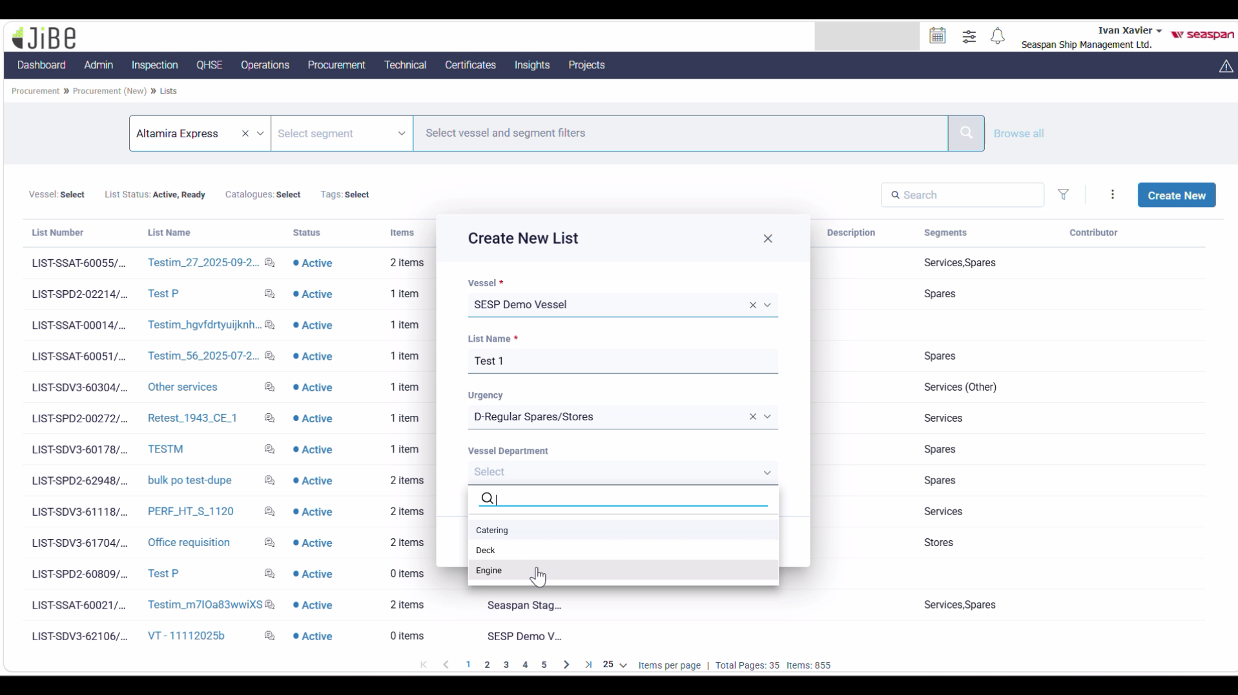
  - The overall section should look like this 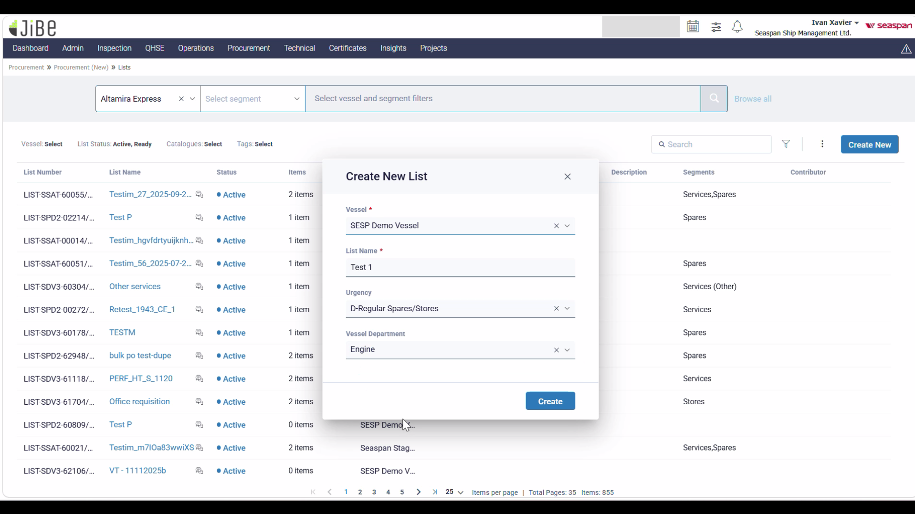
- Click on Create
- The next screen looks like this(Change Ivan Xavier User name Here)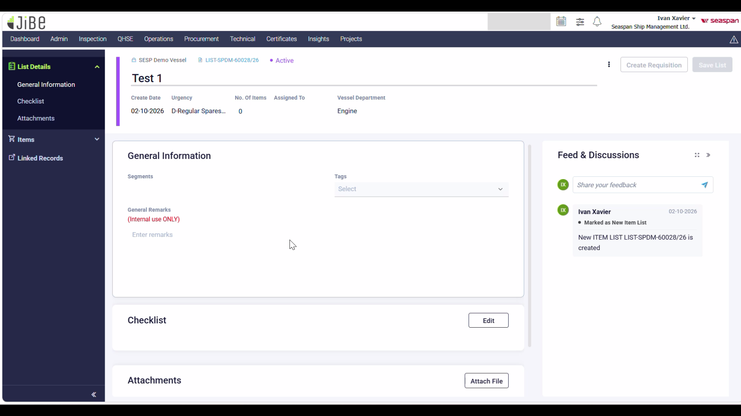
- Click on the “Tags” dropdown under “General Information” and select “MARPOL” and fill the General Remark with test text for now 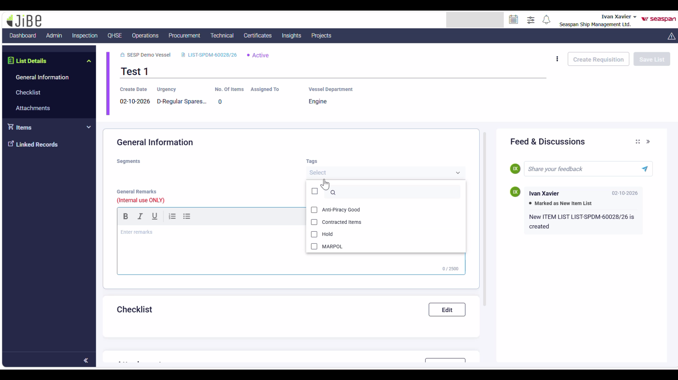
- Then scroll down to Checklist section and click on Edit button 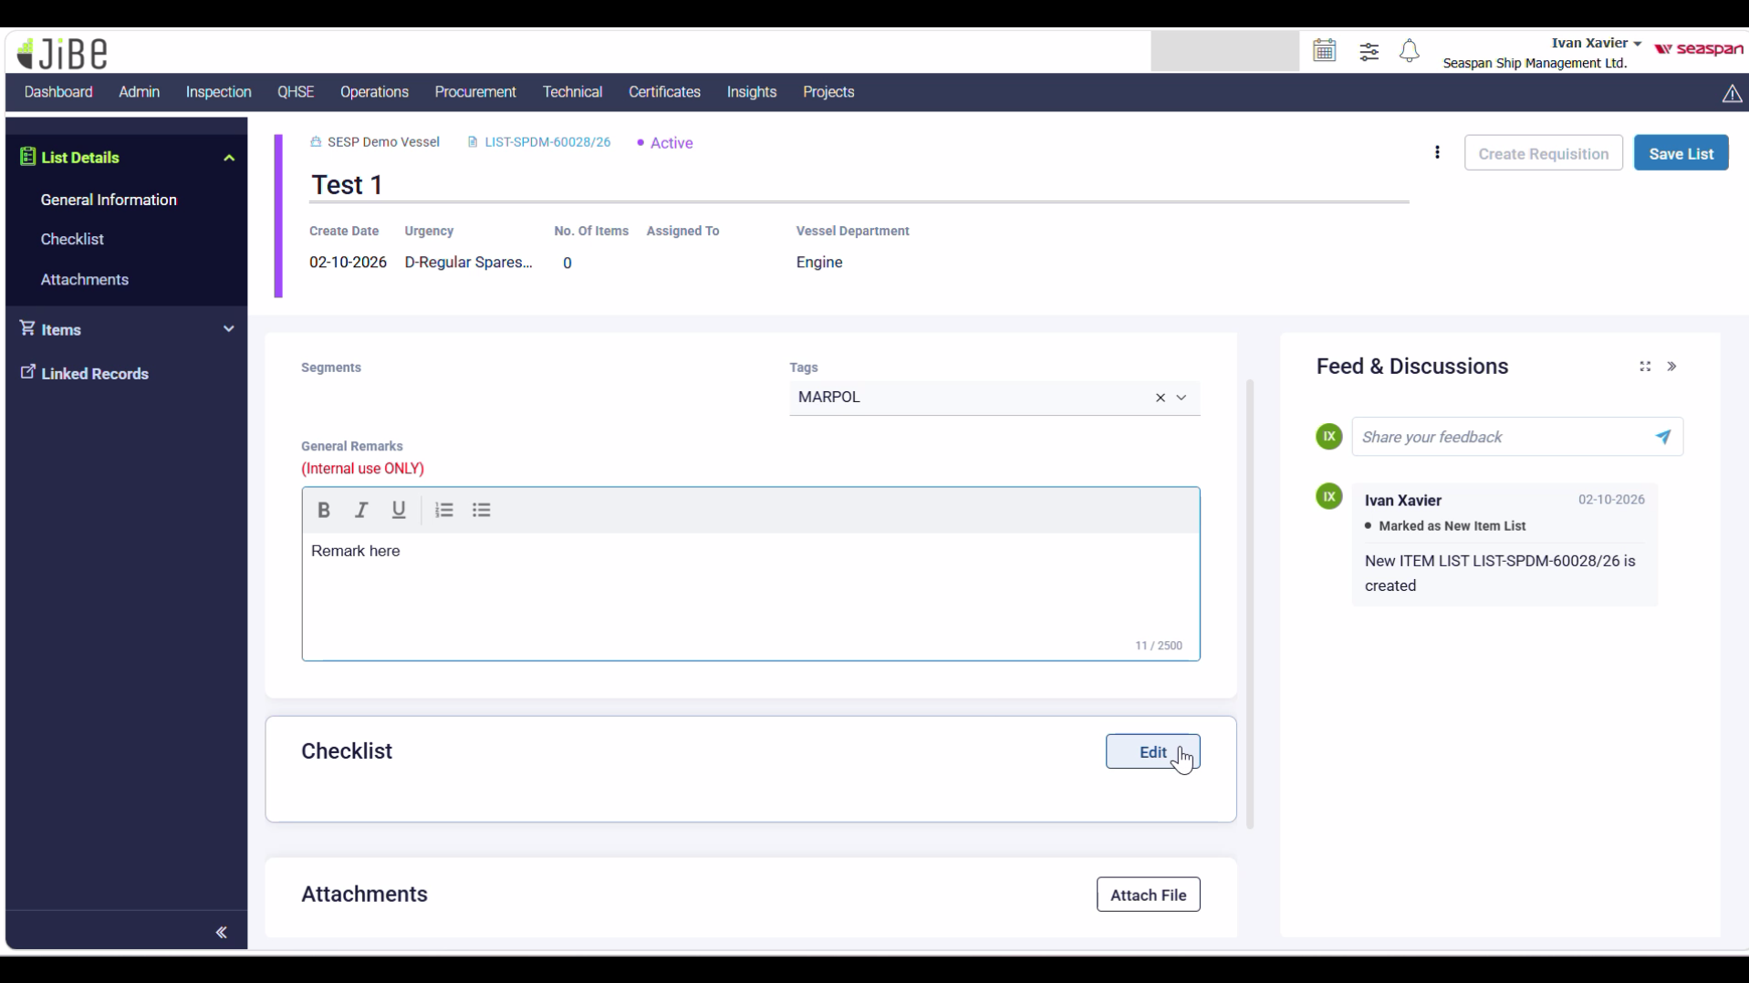
- Click on the Add Checklist and fill it accordingly then add another checklist item below it 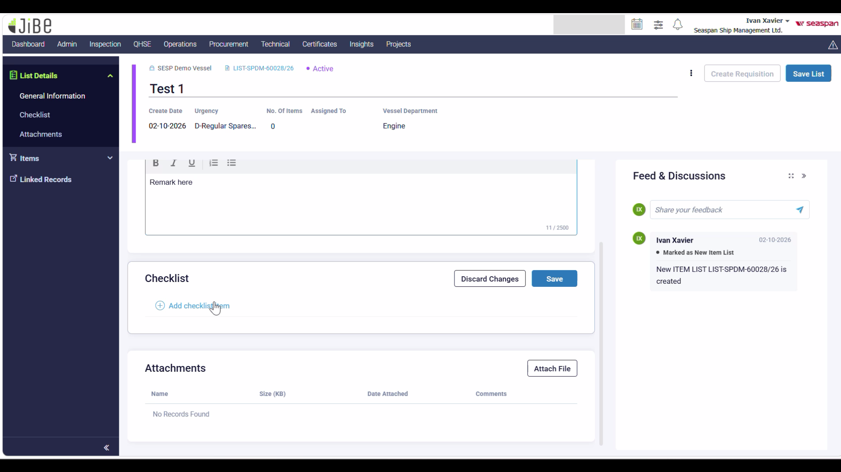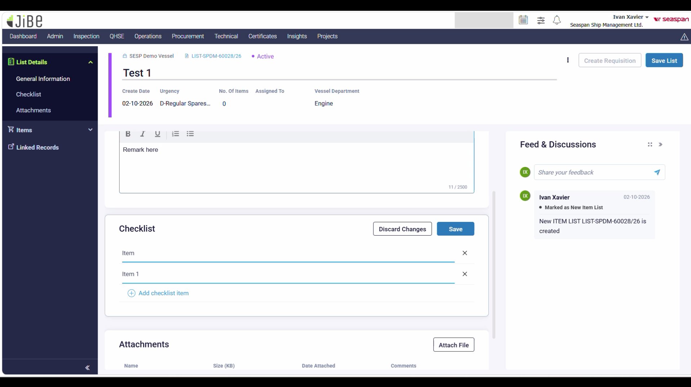
- The “Discard changes” button will reset the checklist (Click only if you want to reset the checklist to empty) OR Use Save button to save the checklist (Which we have to do). Once clicked the UI looks like this: 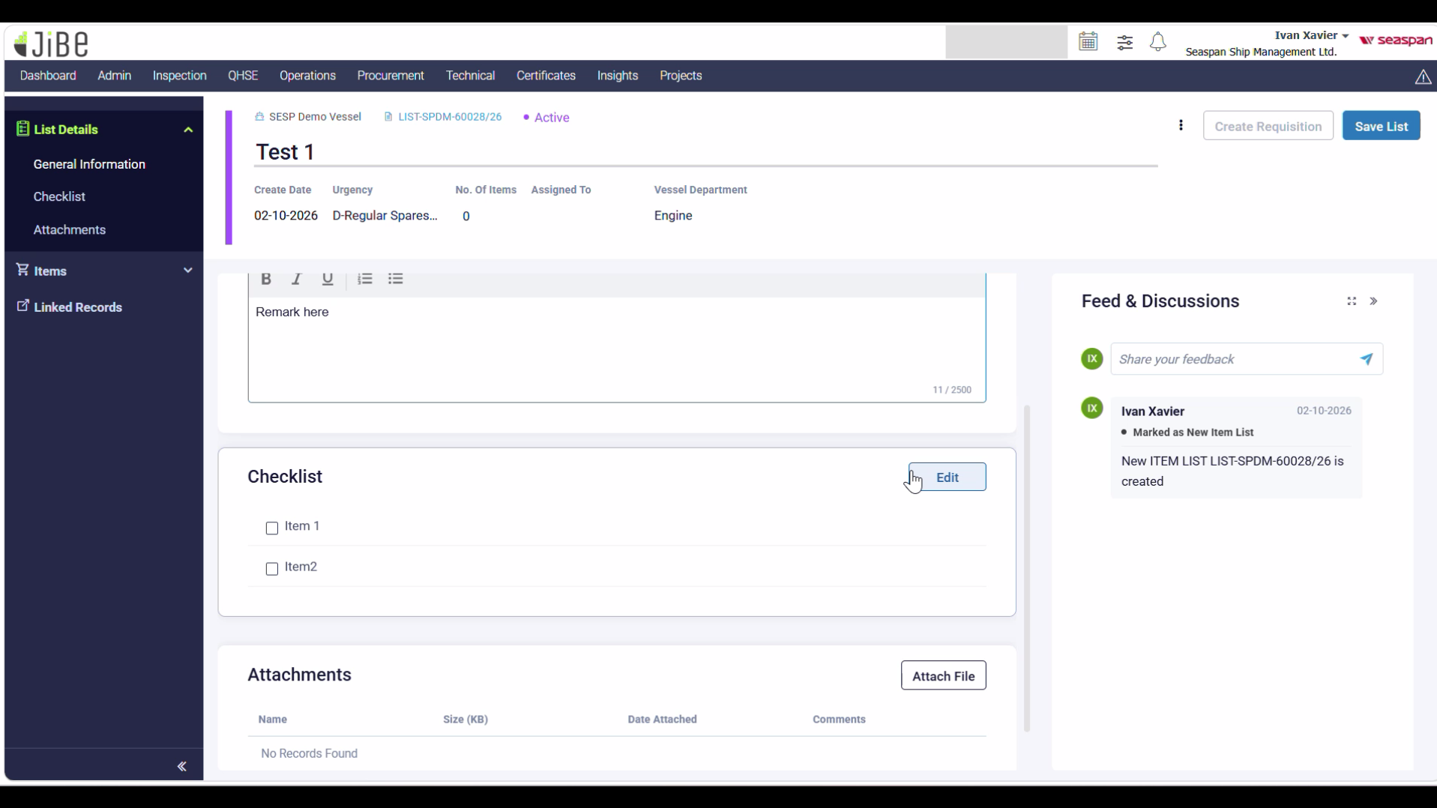
- Scroll Down to Attachments and click on “Attach File” to select a file from your local storage option to add a file here (Only if required) 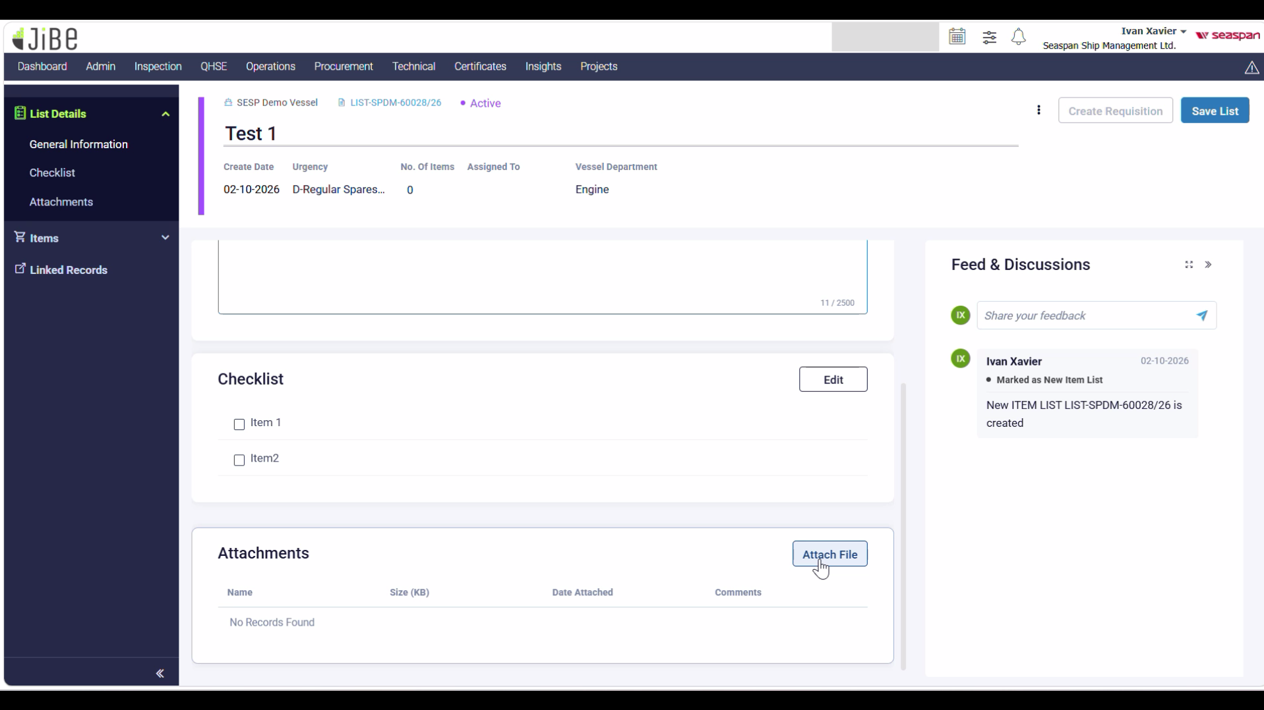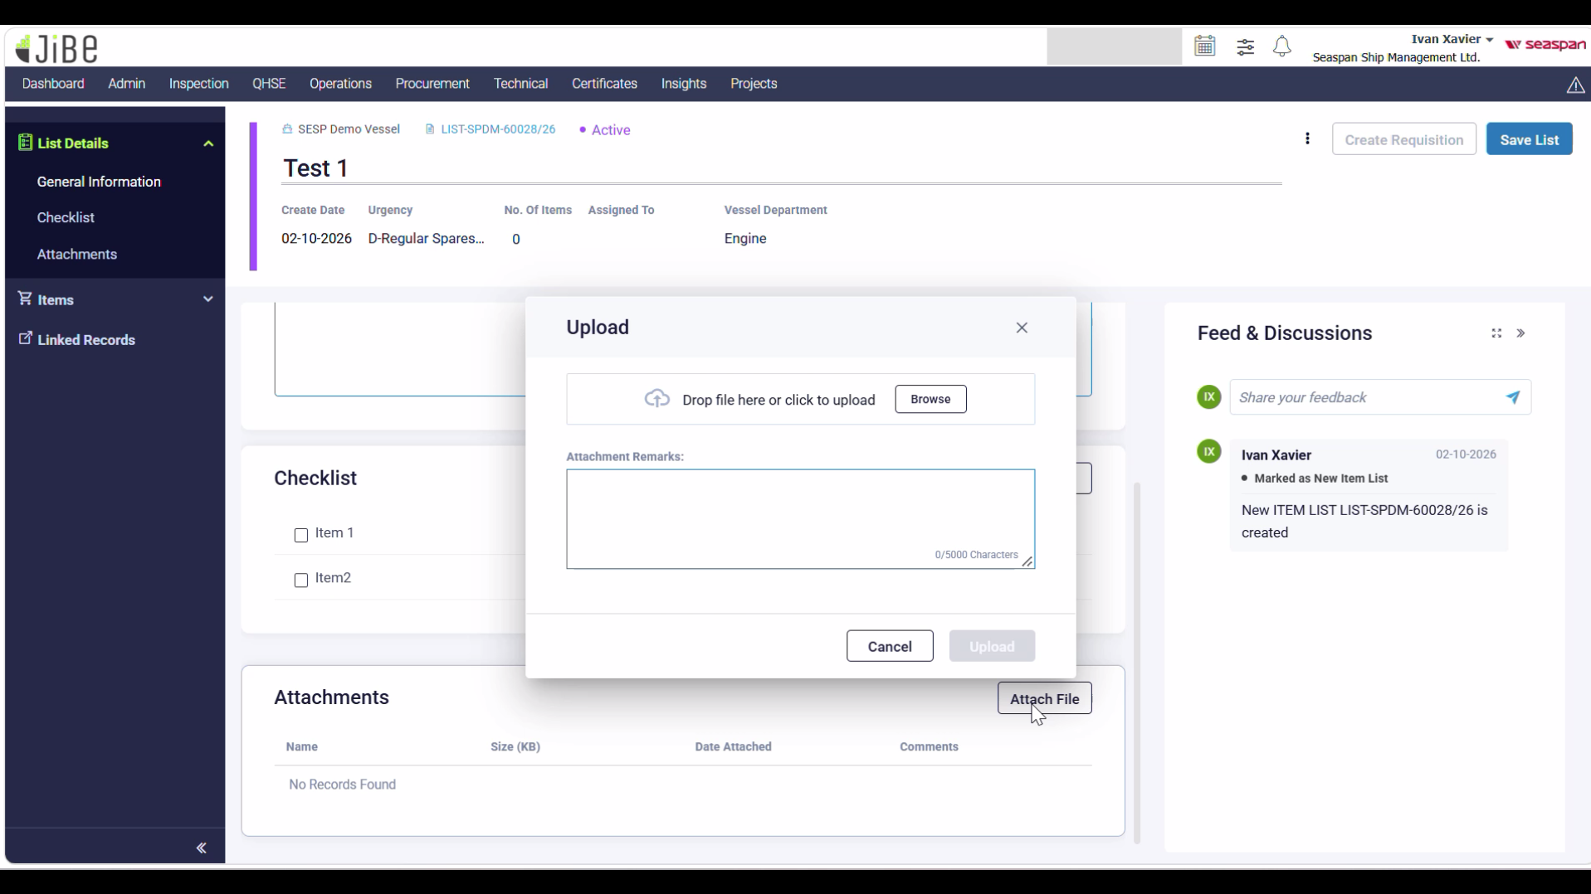
- Then click on the Save list button in the upper right corner to save the list details, then you will have a popup saying “xyz” list saved successfully (“xyz” to be replaced with list name) 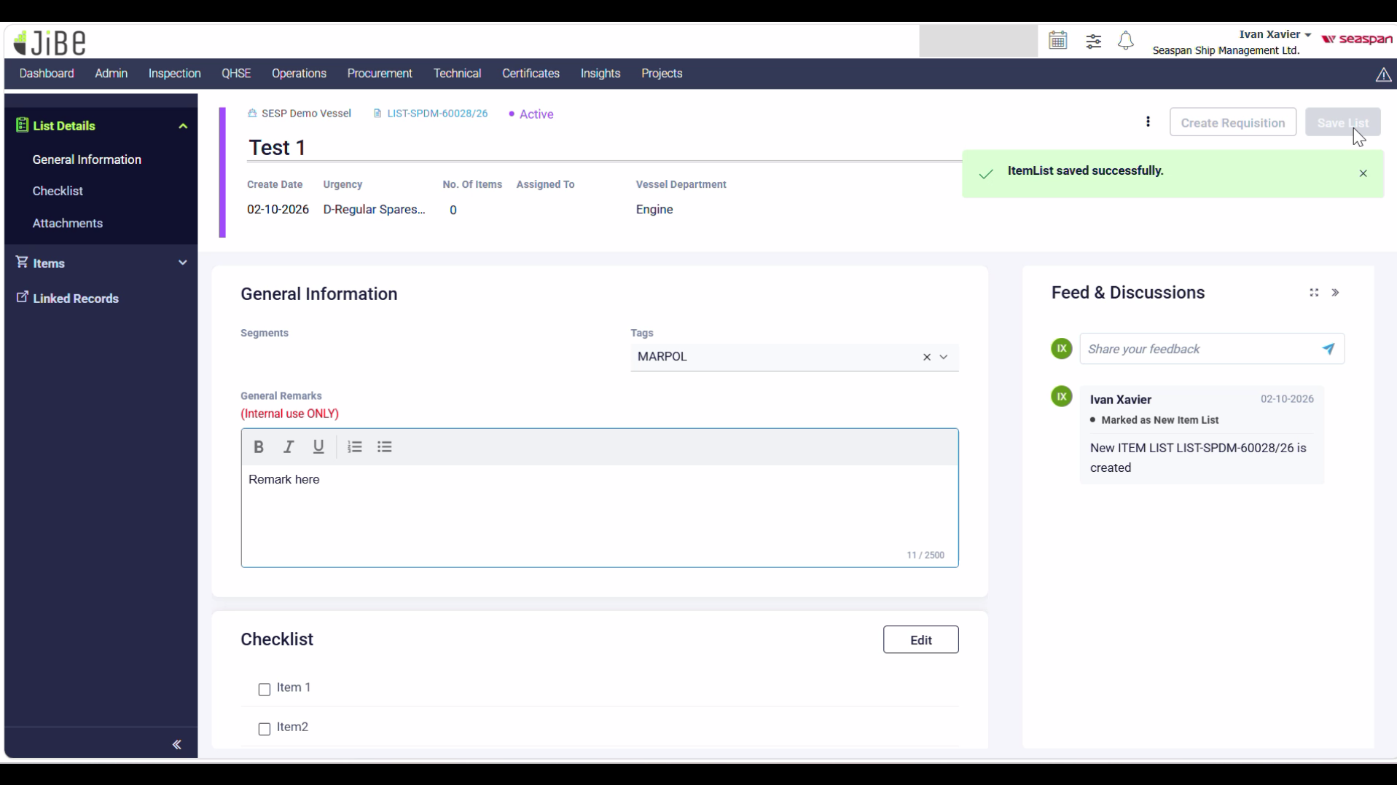
- Then click on the Items under the Items dropdown on the left nav bar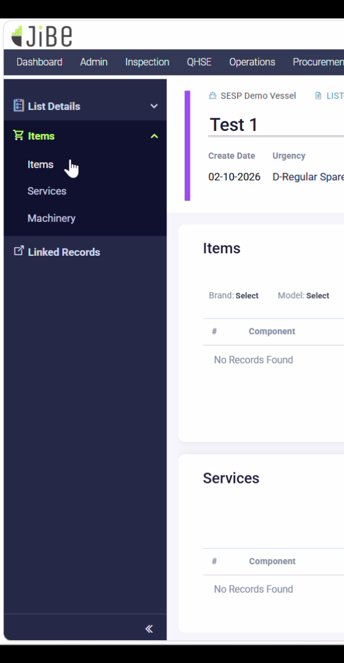
- Click on Browse Items under Items category 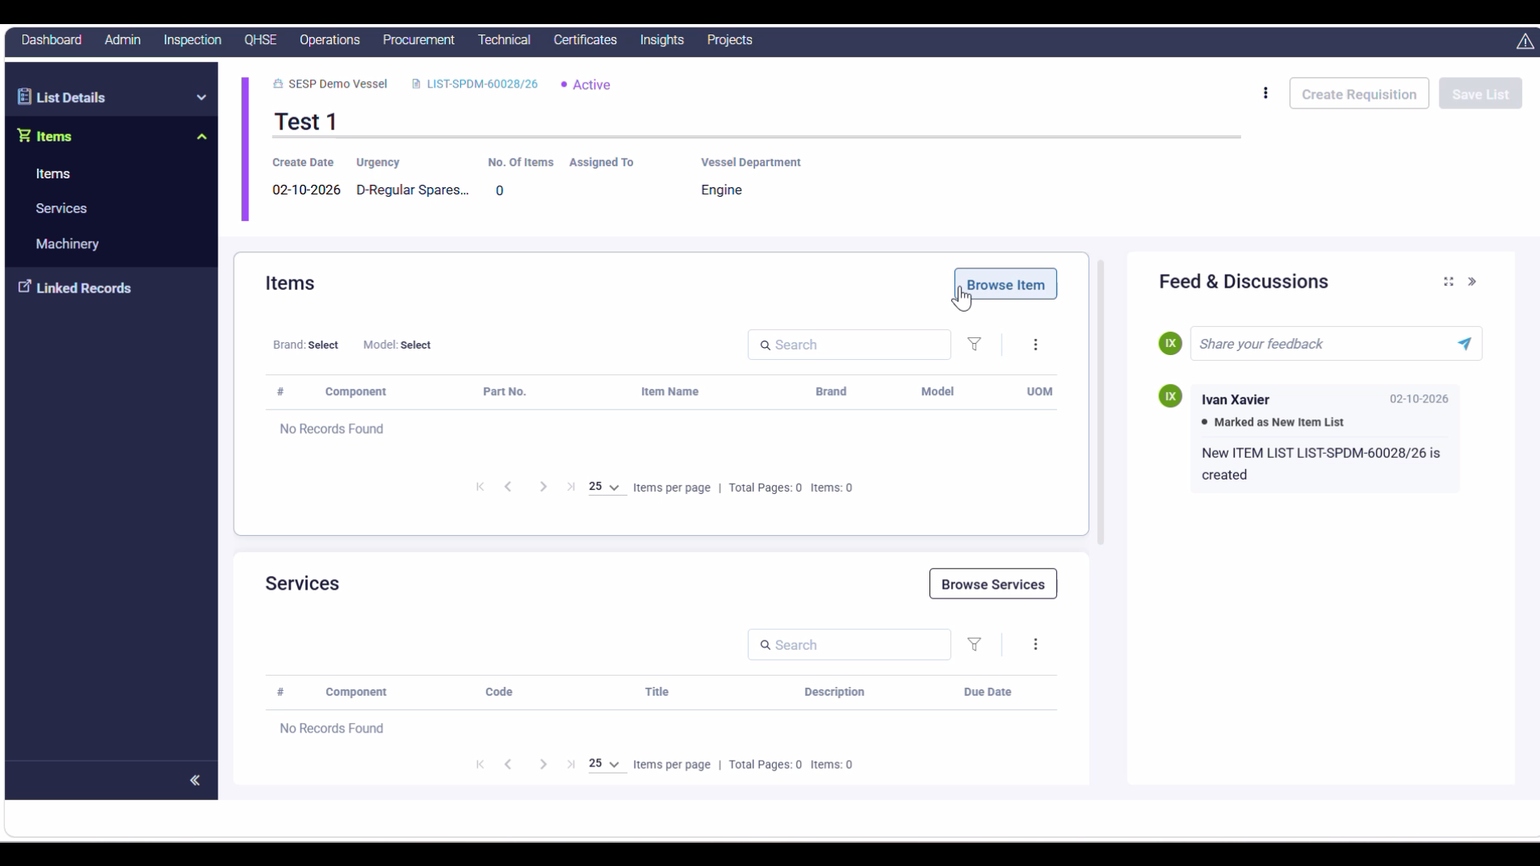
- On next page click on the Chemicals 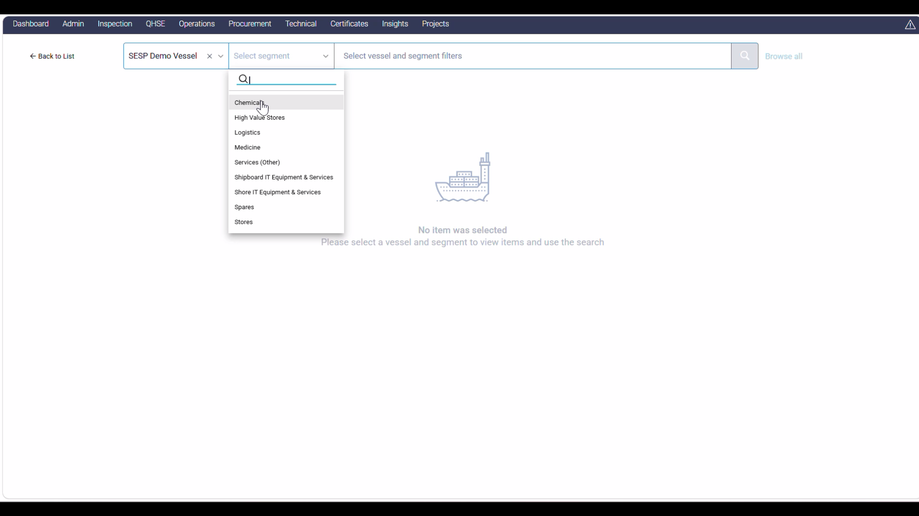
- This will be the updated page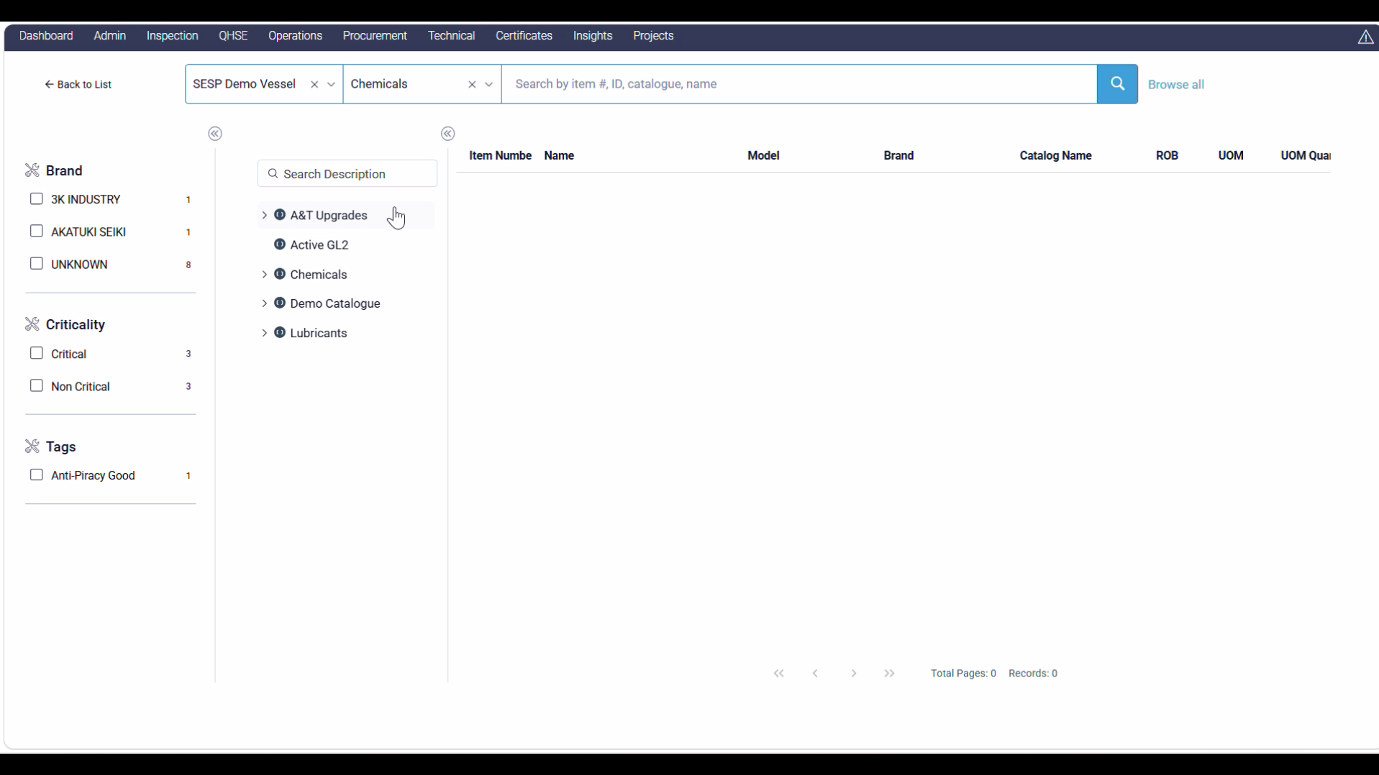
- From the A&T Upgrades menu click on the Enviro… item 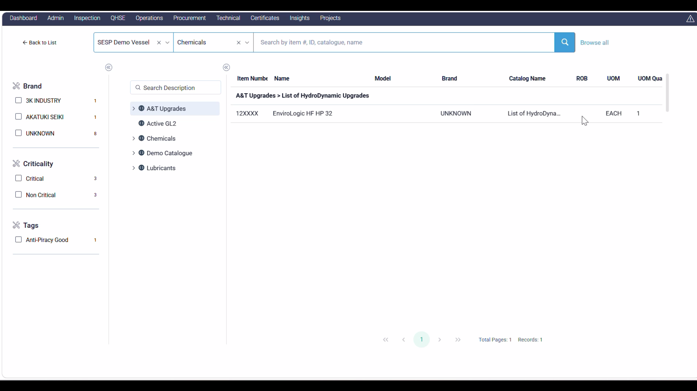
- Once you click on the item it will display the following thing on screen and then select Add to List (Use the number beside it to select number of same item) 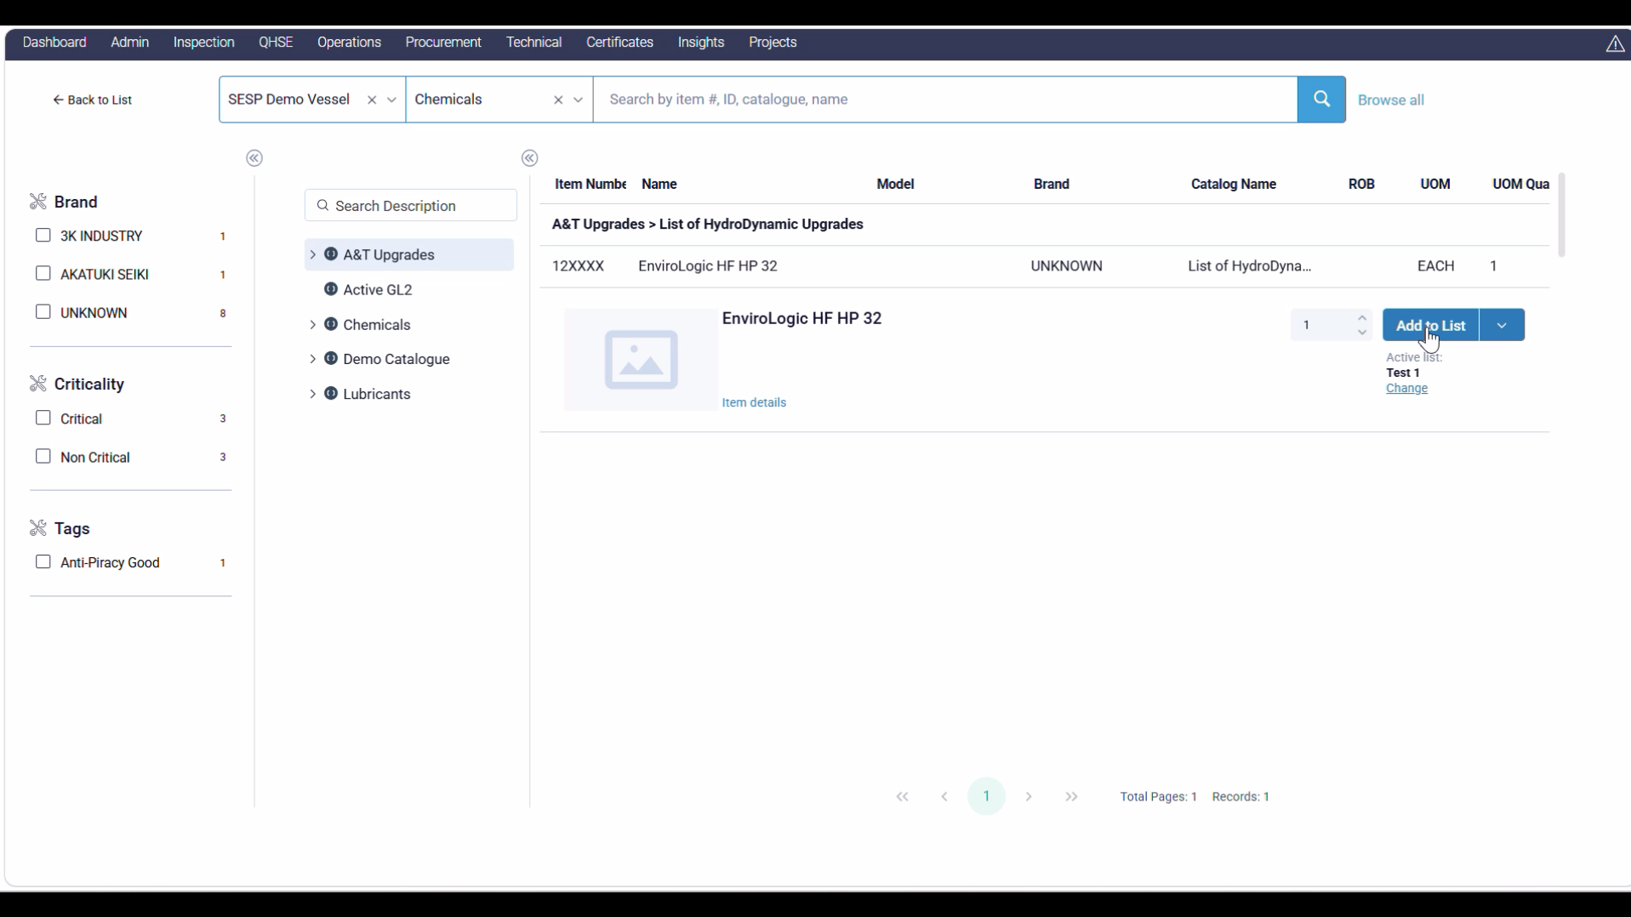
- “Item added to the list” popup will occur 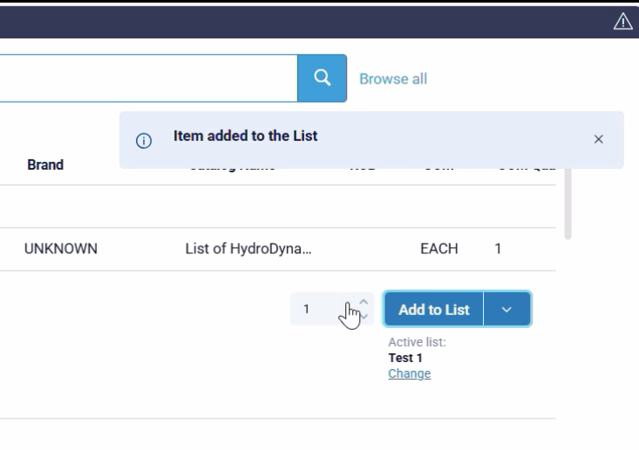
- Click on Chemicals under the sub menu and this will open the clemicals section select the “Test UAT” and then click on the “Add to List” button 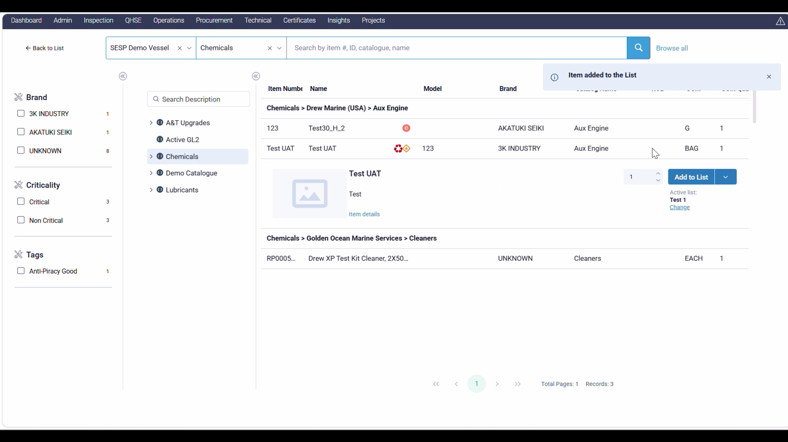
- Move to demo Catalogue and select “Dummy Chemical Segment it…”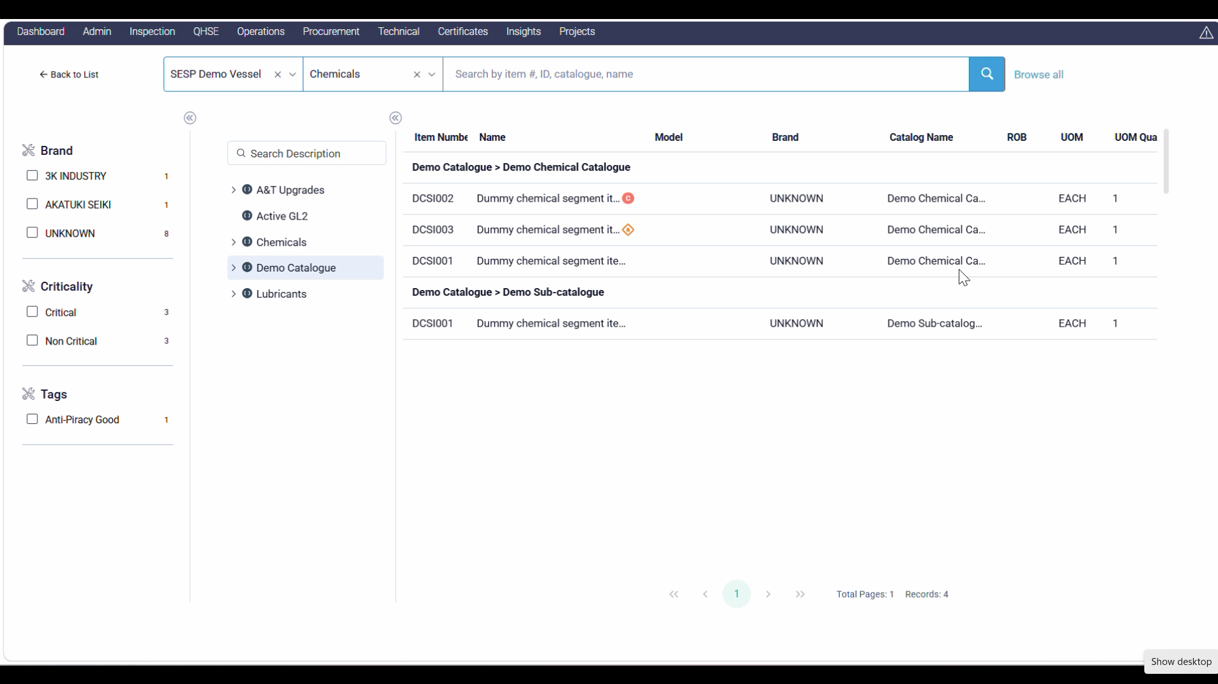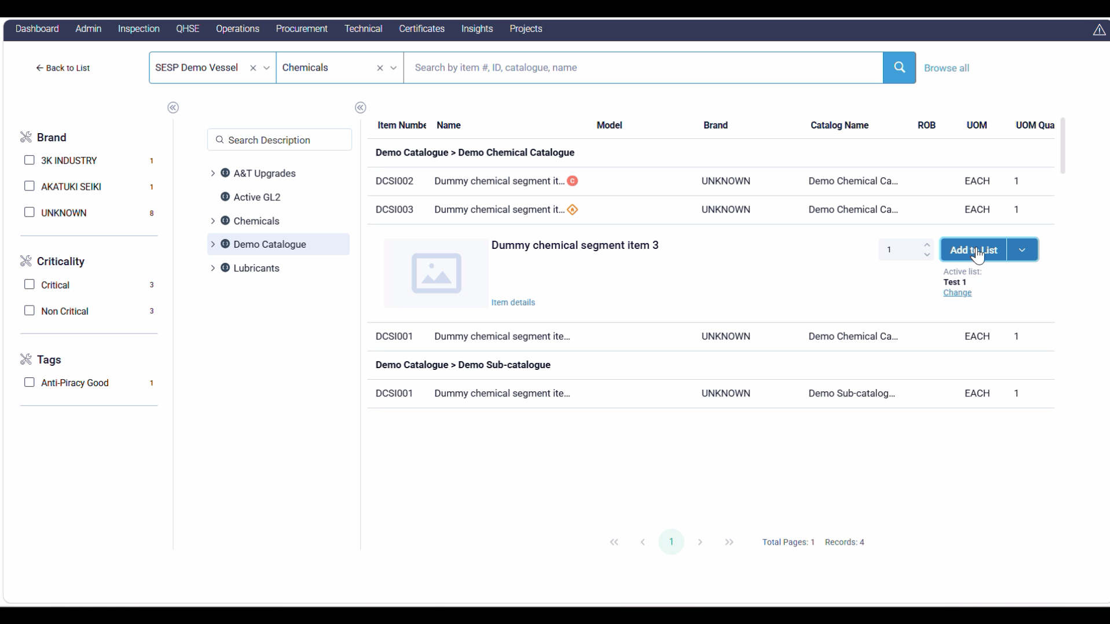
- Then click on the “Back to List” option
- Check the items that you have added from previous items inventory under the “Items section” 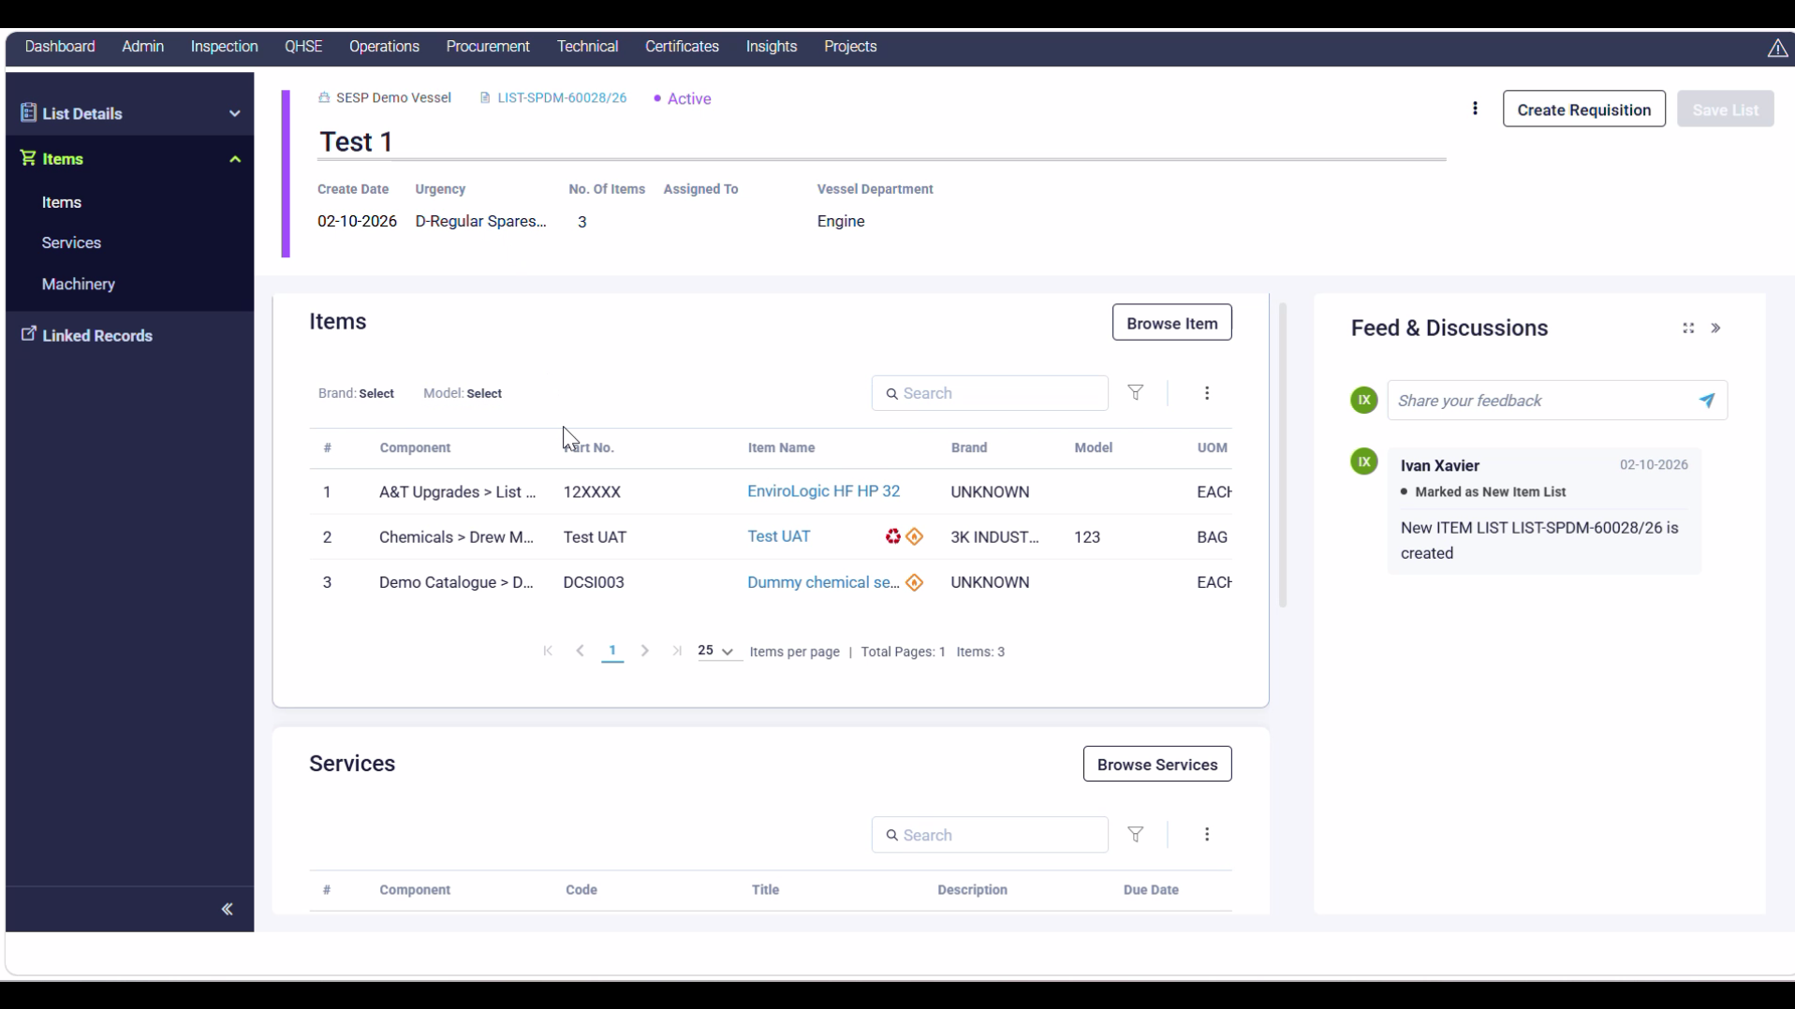
- Scroll down And check for required “Services” and “Machinery”, follow the same procedure as of “Items” but if you add Services to the same list where we have already added Items then it will show the following error: 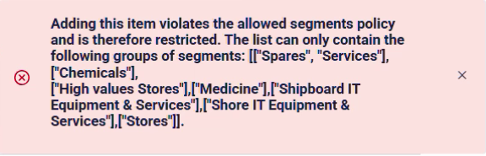
- Click on the “Create Requisitions” button 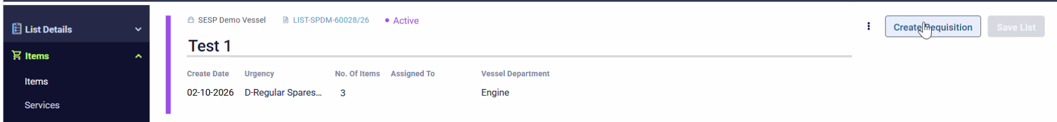
- Create Requisitions box will pup up in the centre of the page like following: 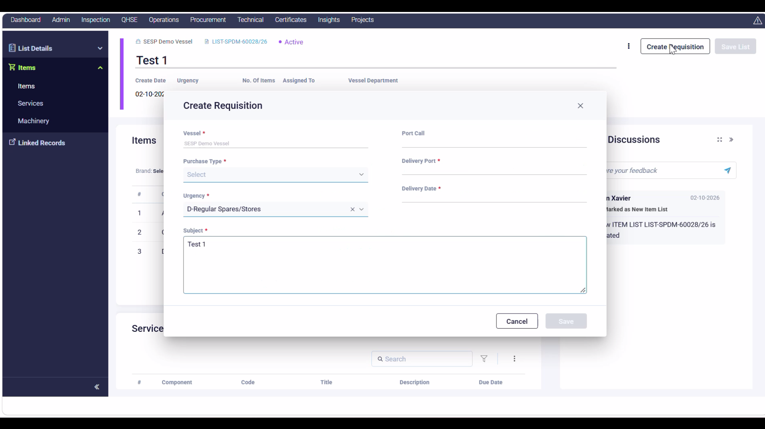
- Select suitable Port call and then select “High Value Stores” under the Purchase Type Dropdown list. 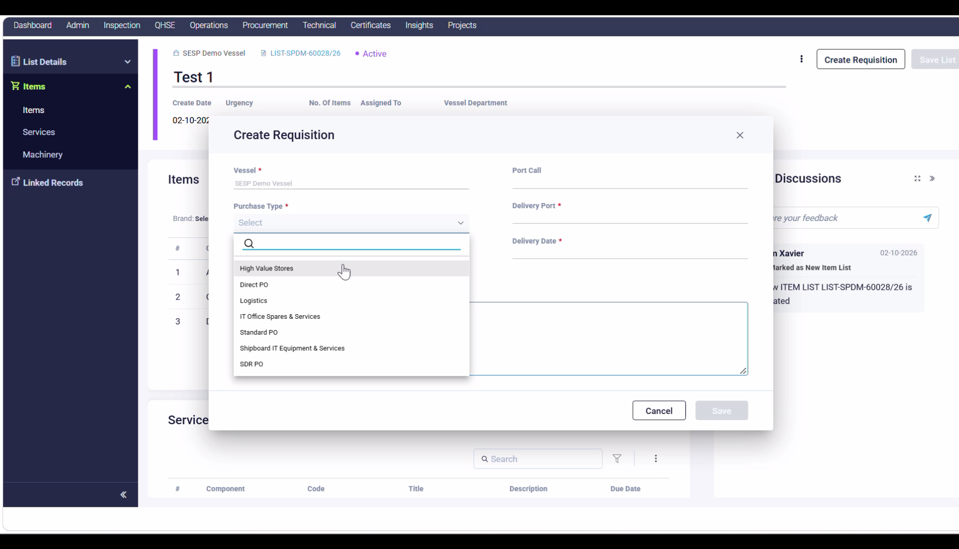
- Then click on the Delivery Port and another box pops up above the existing “Create Requisition” Box, Search and Select your destination port here and then click on Confirm(Which will become blue once you select the destination port) : 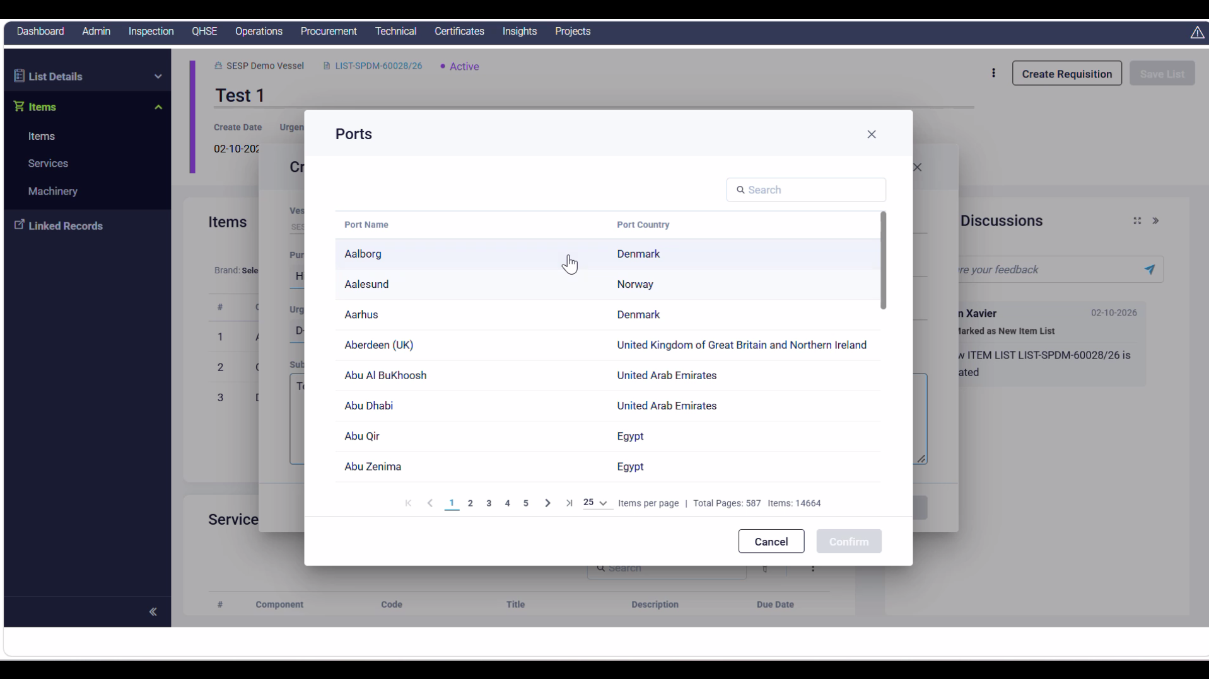
- Then select a Delivery Date (Eg: December 29, 2026): 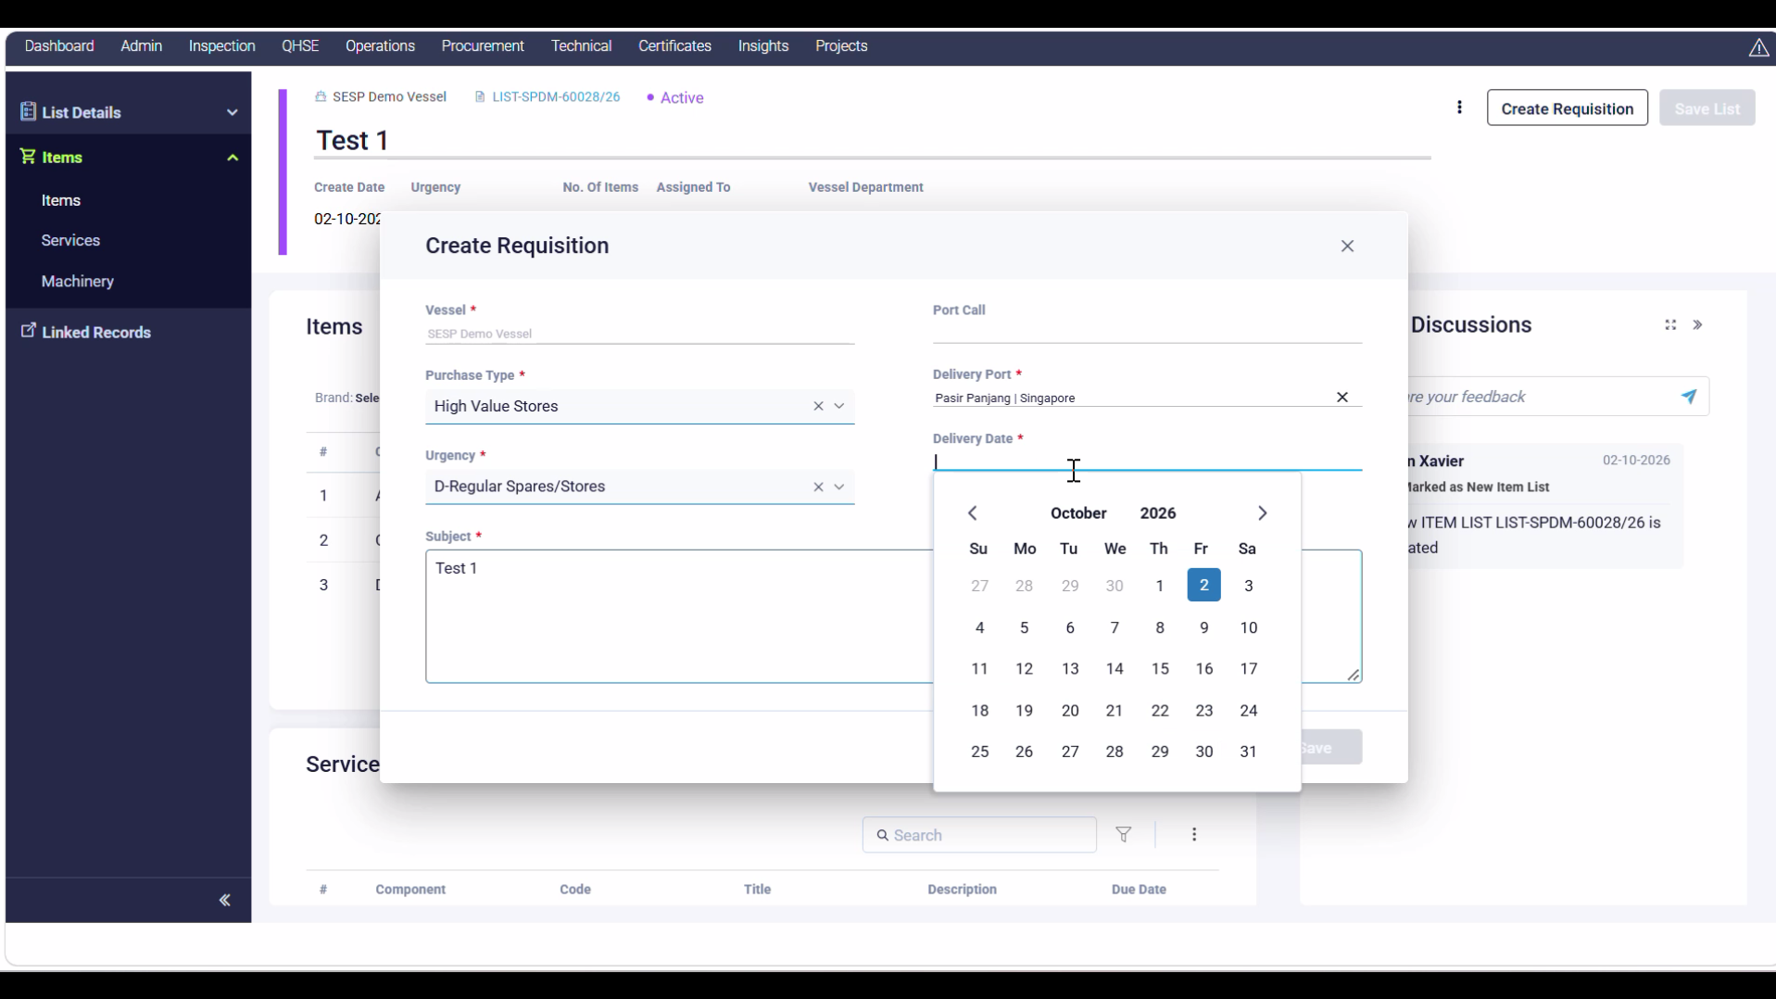
- Type “Chemicals for Deck and Engine” under the subject line instead of “Test 1”, then The overall “Create Requisition” Box should look like this: 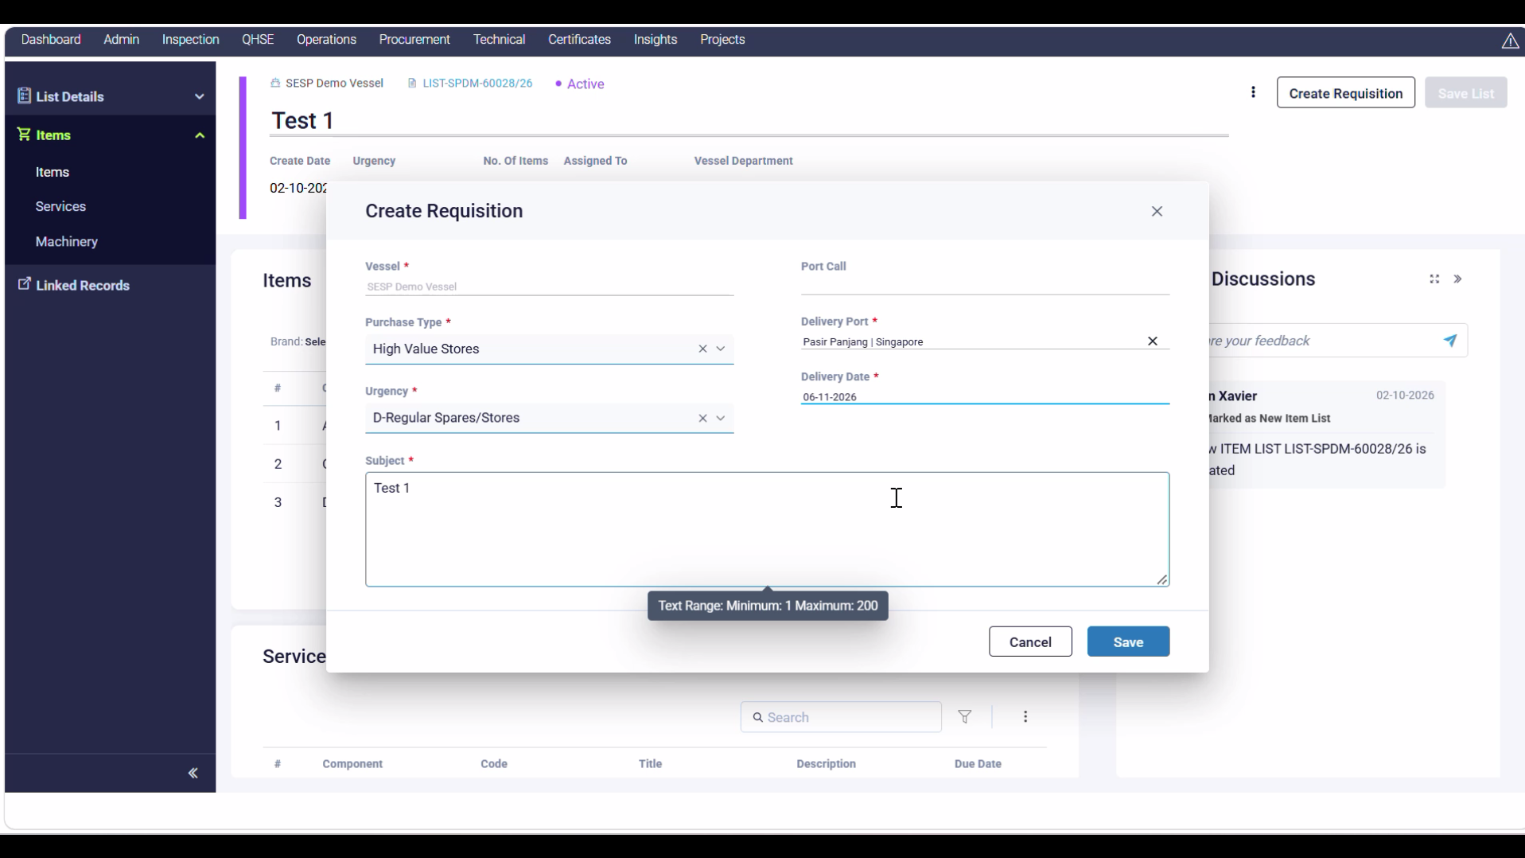
- Then click on Save and click on Confim button that confirming your Requisition Procurement Order 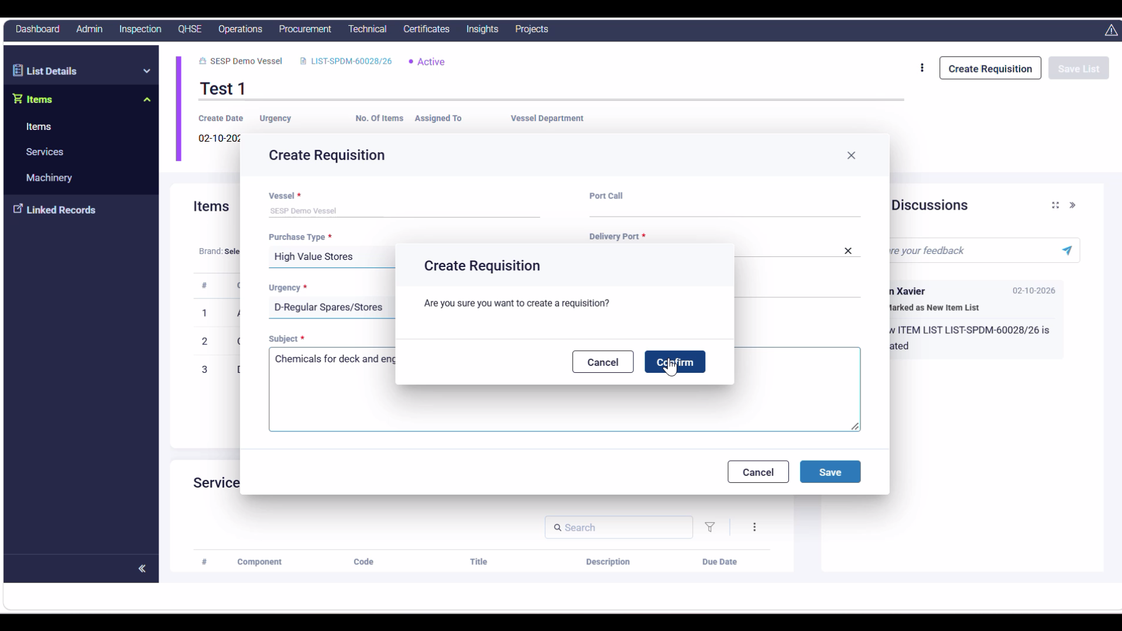
- Then on successful creation it will popup a Requisition successful popup with a clickable link to keep a track of the Order: 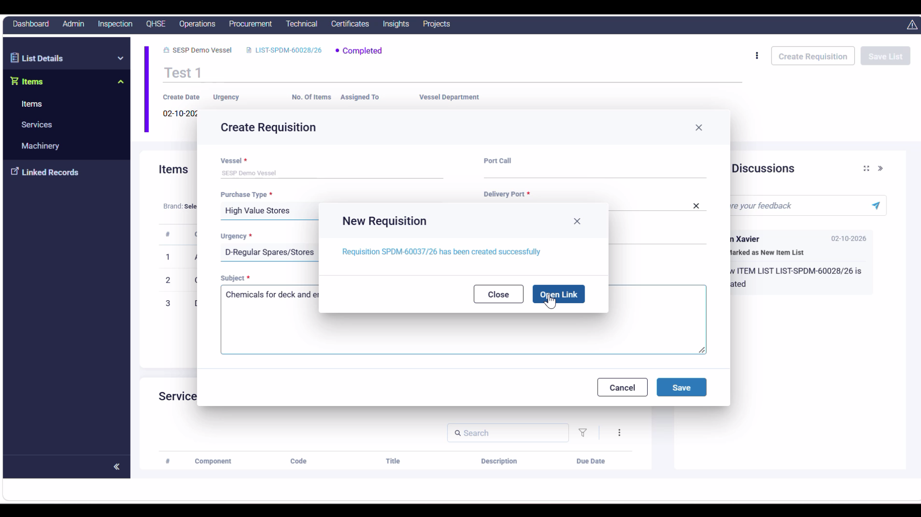

Thank You!

